Thermochromics and ASD Thermal Regulation: Towards ASD Body Architecture Guild lines

Nada Elsonni

**Research objective**

To resolve the relation between architecture, wellbeing, and environment through exploring thermochromics material systems, to create a thermal and touch sensitive prototype, that will help people with Autism and their care givers to detect, learn and cope effectively with their Sensory Processing Disorders (figure 1).

**Figure 1**

**Research Significance**

Autism is the fastest-growing developmental disability (CDC, 2008),one percent of the world population has autism spectrum disorder([CDC, 2014](http://www.cdc.gov/ncbddd/autism/data.html)),1 in 45 children in the U.S have been diagnosed with autism spectrum disorder (ASD) and 90% of those with autism suffer from Sensory Processing Disorders , Architecture, as a profession, is responsible for creating environments that accommodate the needs of all types of users. However, Architects have been just focused on creating architectural building design guidelines to accommodate autistic needs.Though the growing wearable technologies, and architects interest in body architecture, provokes the question of the possibility of designing a wearable to accommodate the needs of ASD’s. This research will introduce the idea of creating body architecture design guild lines

**Wellbeing**

Sensory processing disorder (SPD) is a condition that occurs when sensory signals don’t get organized into appropriate responses (Scott D. Tomchek, 2007) those with Autistic Spectrum Disorder have an overly excitatory nervous system that allows an excessive amount of sensory information into their brains overwhelming the structures that is responsible of discriminating between various types of information, causing them to be either hyper/hypo sensitive to stimuli, SPD effects negatively on their social interaction, causing anxiety and melt downs, along with stress to both patients and their care givers.

In this research the focus will be placed on thermal regulation, tactile sensory disorder as a part of the sensory discrimination disorder

**Thermal regulation**

It’s a condition when the body is unable to set internal thermometer at a comfort zone, exhibiting hyper or hypo sensitivities to heat and cold. Autistic people are hyper sensitive to sensory pain and hypo sensitive to physical pain, as their nervous system is over whelmed, they might not sense pain. This problem along with thermal regulation problem can lead to serious complications and life hazard, such as getting burned, either by being exposed to the sun for so long, or touching a hot object.

**Tactile**

Touch in ASD’s has been described as an intense feeling that can be overwhelming and confusing (Scott D. Tomchek, 2007).Researchers reported over responsivity to tactilein people with autism, as light touch can be truly disturbing , it can send an amplified alarm signal to the brain causing anxiety and melt downs.

**Body Architecture**

The history of the relation of the human body and architecture goes back to Vitruvius attempts to relate build­ings to the proportions of the human figure, recently, architects have been interested in fashion industry to explore the relation between body and architecture, this interest along with the advancement of computational and 3D printing technologies, encouraged other architects such as Neri Oxman(figure 3,4), Bahnaz Farahi (figure 2 ), Philip Beesley, Julia Korner, and Daniel Widrig to collaborate with leading fashion designers such as Iris van Herpen

The term “Body Architecture” has been mainly used among artist such as the avant-garde media artist, Stelarc, and Lucy McRae to transform conceptions of the human body (Farahi, 2016).In the context of this research, body architecture is a form of proto-architecture that will help human body communicate and cope with its surrounding environment.

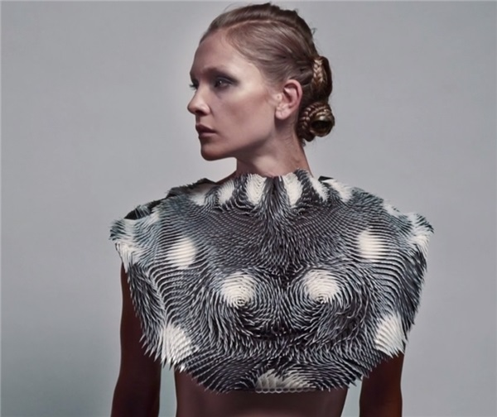

**Figure 2**: Caress of the Gaze by Bahnaz Farahi a wearable that react to human eye gaze .

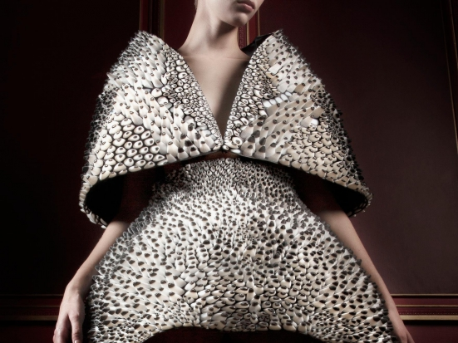

**Figure 3:** Voltage 3D printed cape and dress collaboration between Iris Van Herpen and Neri Oxman

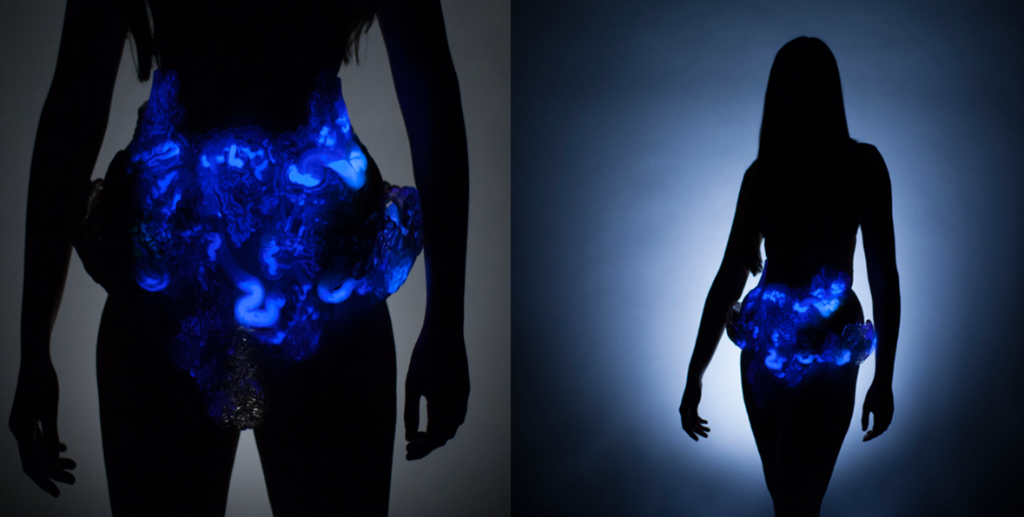

**Figure 4:** Mushtari by Neri Oxman is amicrobial factory that uses synthetic biology to convert sunlight into useful products inside a 3D printed wearable

**Thermochromics Material System**

Just like human’s sensory processing nervous system, Smart materials are materials that sense environmental events, process that sensory information, and then act on the environment. Transiency, selectivity, immediacy, self-actuation and directness are the main characteristics that distinguish Smart materials from other common materials that is used in architecture(D. Michelle Addington, 2005).

In the architecture field, property change class is the class of smart materials that has most potential applications. What defines this class is that change occurs in the chemical, thermal, mechanical, magnetic, optical, or electrical property responding to a change in the conditions of the environment of the material. This class includes all color changing materials, such as thermochromics, electrochromics, photochromics, etc.

In this research will explore thermochromic material systems. Thermochromic is an input of thermal energy that alters the material molecular structure. The produced molecular structure will demonstrate different spectral reflectivity than does the original structure, which will change the material’s color and its reflected radiation in the visible range of the electromagnetic spectrum (figure 5), because of the color responding capability of a thermochromic material can be used directly as a device for sensing environment temperature change (D. Michelle Addington, 2005) Thermochromics applications in the field of architecture are limited to being a tool of expression, some examples are in furniture design, Jurgen Mayer H.’s furniture to show the past presence of a person at a particular location(figure6).

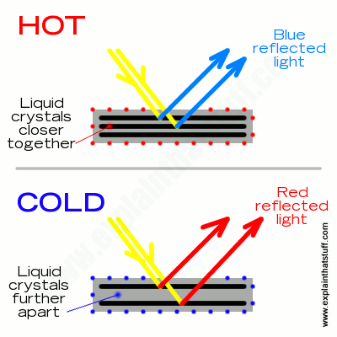

**Figure 5**

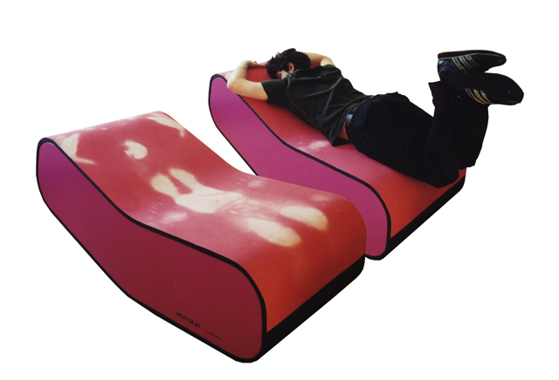

**Figure 6**

**Methodology**

Material Computation, is the methodology and the technical framework, that will be conducted in this research, by modeling, simulating and fabricating functional material organizations while varying properties to correspond to various functional constraints. Within each process, certain methods will be identified to rethink the design not as form-driven, but as a behavioral driven paradigm (Oxman, 2012) To facilitate this approach, a three-phase process will be conducted to choose the material, form, and the fabrication method of the final prototype.

**Series of Material Testing:**

A small scale thermochromic material systems experiments will be conducted to create a reactive material to temperature, three main variables will be tested in this phase, the ratio between materials, temperature range and the amount of pressure applied.

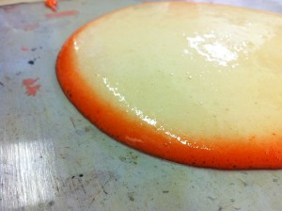 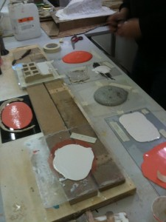

**Figure 7**

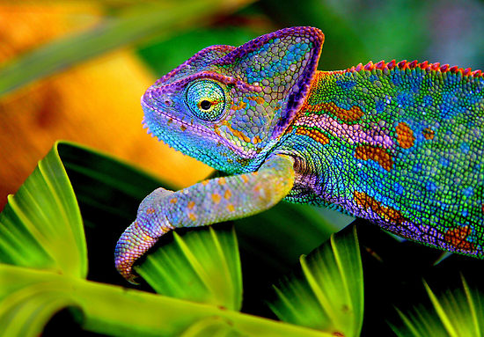

**Figure 8**

**Prototype Morphology Testing**

The main objective of this phase is to design a wearable prototype that hugs the ASD ’s body and work as a temperature indicator while encouraging firm touch by its thermochroic reactive property. However, there is three design constrains that will control this process, the prototype must provide enough surface area in order to visually demonstrate the reactive themochromic property when firm touch is applied, the surface also has to be flexible enough to provide comfort and allow normal movement, moreover the surface must be smooth to encourage deep pressure touch prototype fabrication testing .Two main form mechanisms will be tested, a form that demonstrate auxetic behavior(figure 9), and a form that combines rigid and flexible elastic elements (figure 10), in each form there are three main variables to be tested; scale, geometry, material behavior and density. The main 3d modeling software that will be used in this process will be Rhino, as it represents the common digital fabrication language between all fabrication tools that will be used in this research.

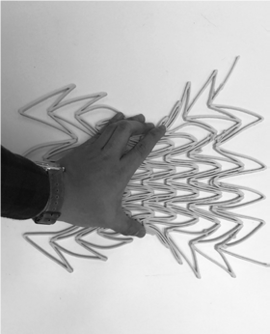

**Figure 9**: Auxetic Behavior

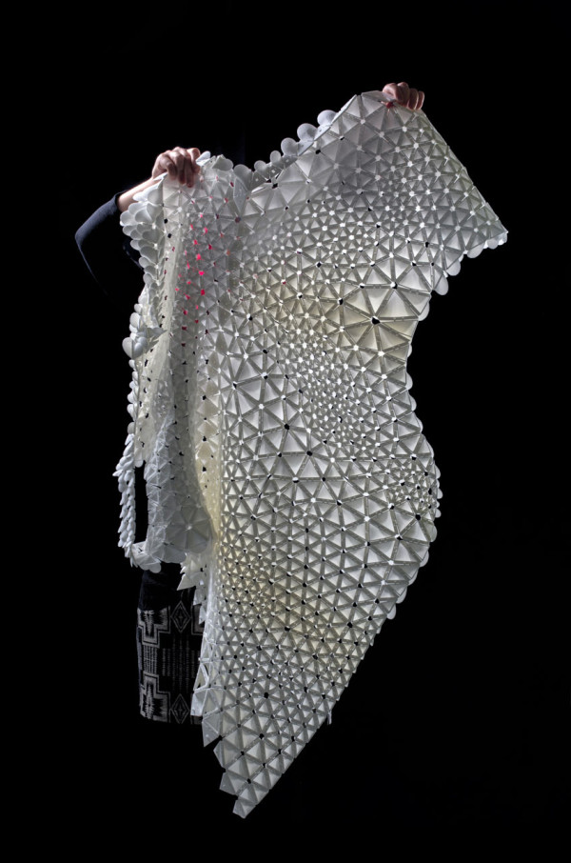**Figure 10**: A form that combines rigid and flexible elastic elements

**Prototype Fabrication testing:**

For each thermocromic system that will be tested, a different fabrication tool will be used, the 3axis CNC machine, and the hot wire robot will be used to create a foam mold for casting thermocromic silicone in two different ways, solid to void and void to solid. Selective laser sintering (SLS) which is an additive manufacturing (AM), will be used for the thermocromic filament. The design will consist of interlocking component that is rigid, but when aggregated, it’s expected to behave as a continuous flexible textile.

**Register _ React _Report**

This phase will include embedding the wearable with pressure sensors and heart monitor, this phase will be divided into three steps ,the three Rs, the first step is the wearable will register the pressure assigned through firm touch, and heart rate through the heart rate monitor, the second step will be react, the reaction will be visually by changing color responding to temperature change or pressure applied, and auditory through the heart monitor alarm when the heart rate exceed normal range, the last step to report to a mobile app that will register temperature change, the heart rate data ,and the change in heart rate in coloration with applied pressure(figure11,12).

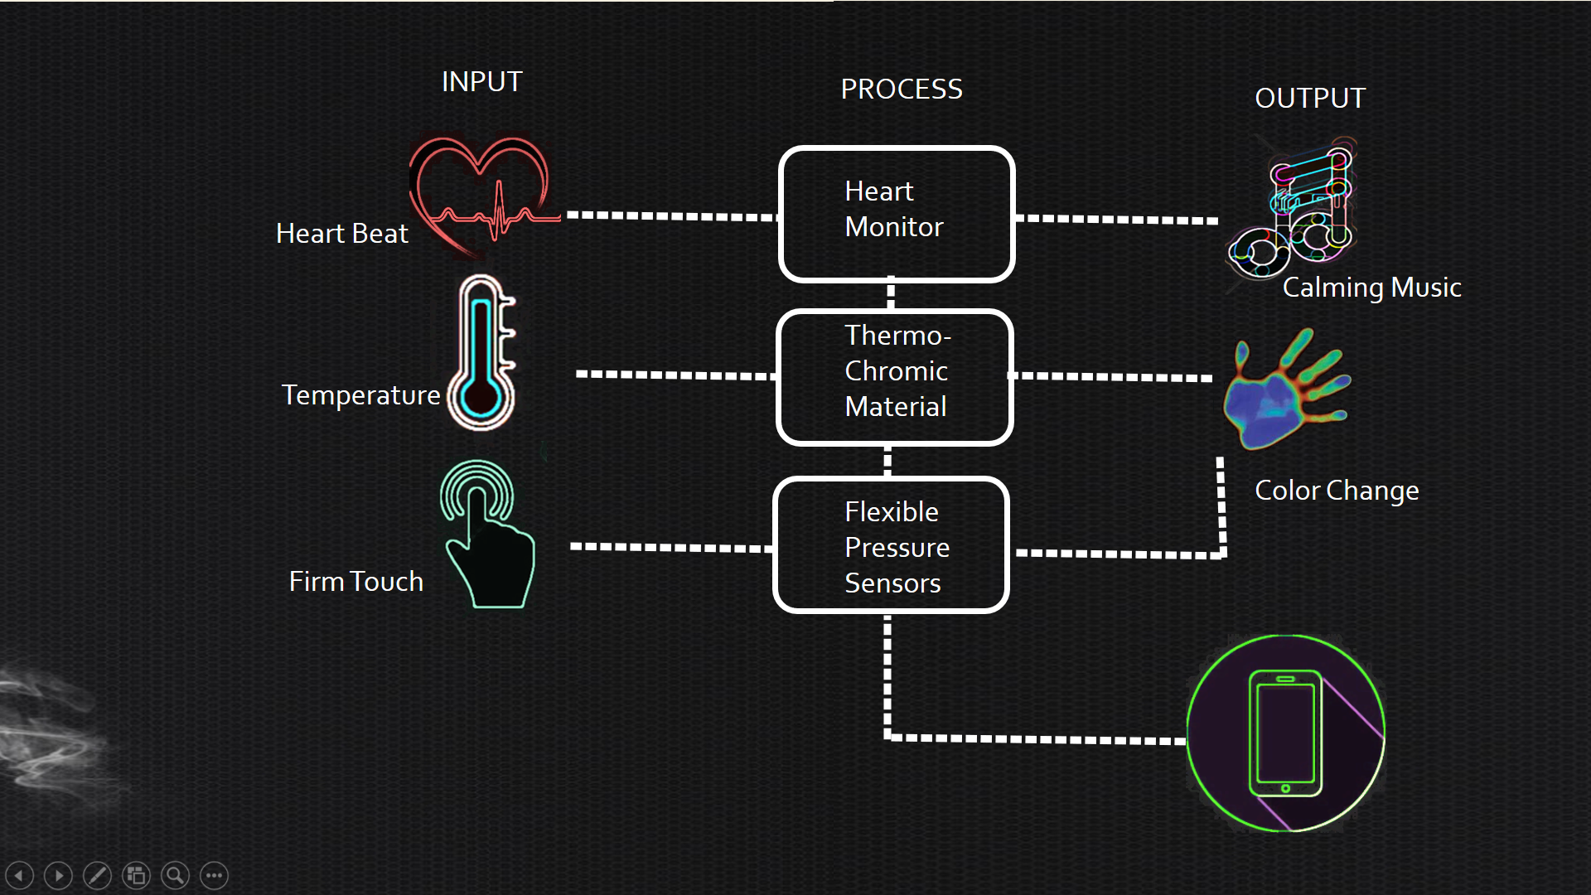

**Figure 11:** Input and Output Diagram, demonstrates the Register-React-Report process

[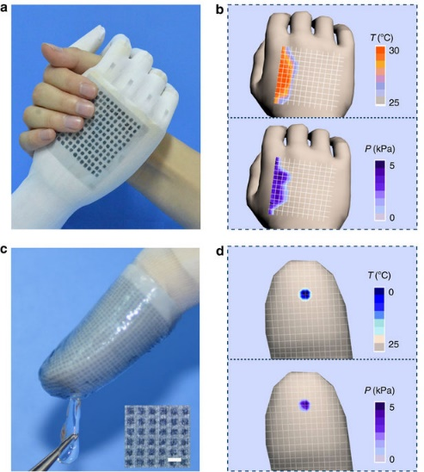](http://www.nature.com/articles/ncomms9356/figures/6)

**Figure 12:** Performance of flexible MFSOTE matrixes.

**Expected Results**

The expected result of this research is a prototype wearable that can register touch and temperature change by reacting visually, through color change property of thermochromics material system of, physically through embedded pressure sensors, and auditory through soothing music alarm when the heart rate monitor indicates abnormal heart rate. This wearable is expected to help people with ASD and their care givers to cope with their thermal regulation disorder through detecting temperature change, and encouraging deep touch pressure, to improve ASD’s ability to cope effectively with their tactile and thermal sensory disorders stress and anxieties, and eventually hope to provide them with a better quality of life (figure 13).

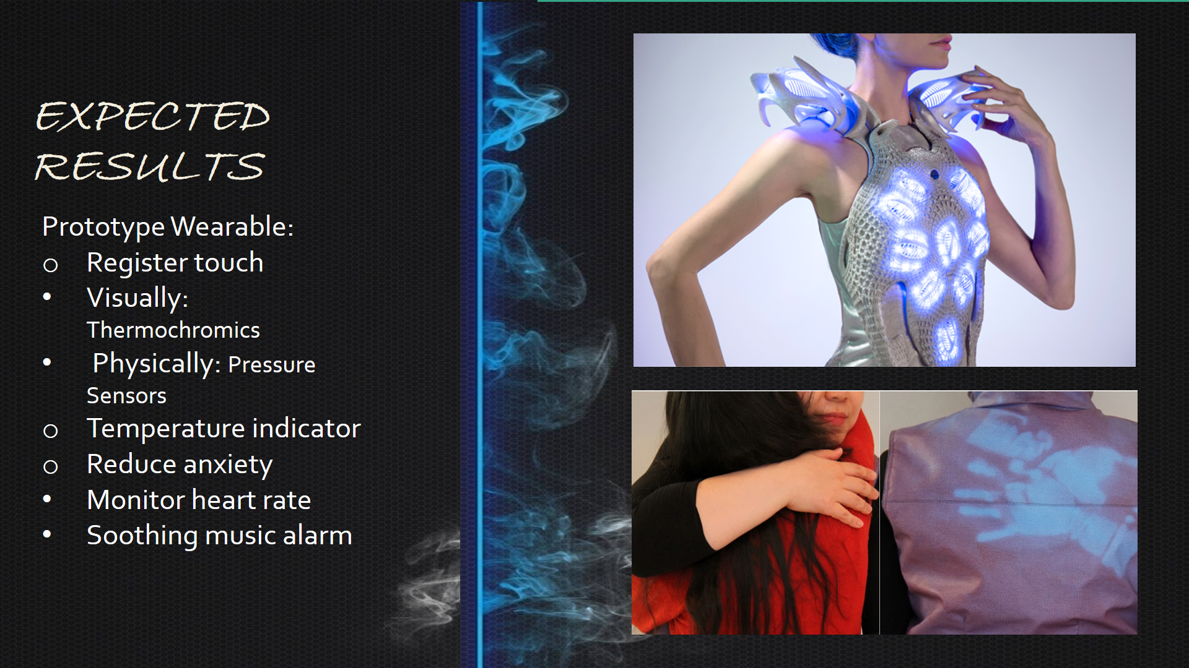

**Figure 13**

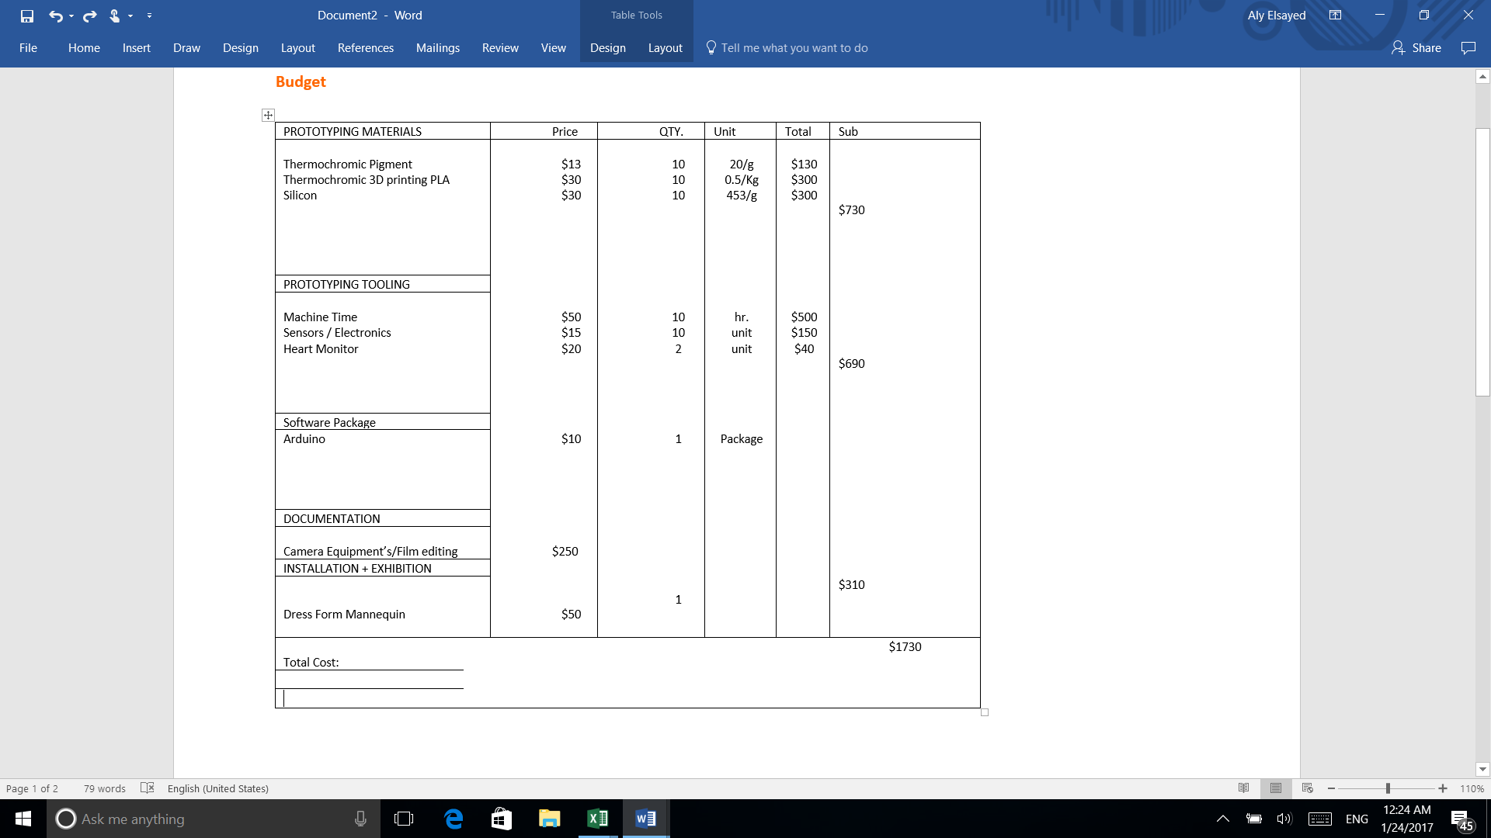

**Source of Funding:** 1500 $ Rackham Grant + 230 Ms of Architecture program budget

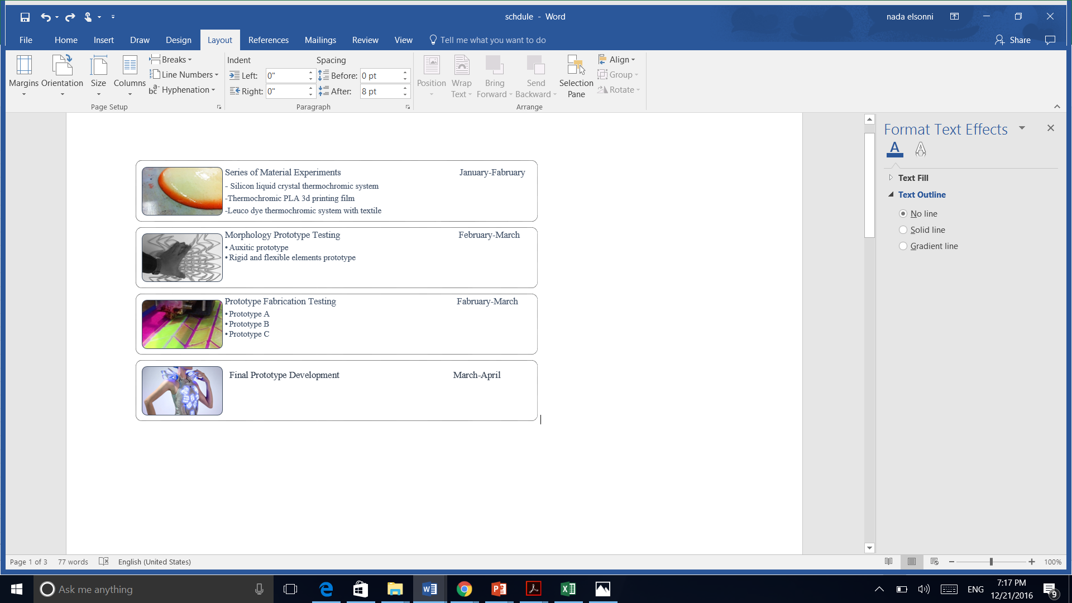

**Research Timeline**

# References

Autism, S. o., 2015. *Autism Tips for Emergency Responders: Temperature Regulation.* [Online]   
Available at: http://spiritofautism.org/autism-tips-for-emergency-responders-temperature-regulation/  
[Accessed 21 12 2016].

CDC, 2016. *CDC.* [Online]   
Available at: https://www.cdc.gov/features/dsdev_disabilities/

D. Michelle Addington, D. S., 2005. *Smart Materials and Technologies.* 1st ed. s.l.:Elsevier.

Farahi, B., 2015. *Behnaz Farahi.* [Online]   
Available at: http://behnazfarahi.com/synapse/  
[Accessed 5 12 2016].

Farahi, B., 2016. *Caress of the Gaze: A Gaze Actuated 3D Printed Body Architecture.* Michigan, ACADIA.

Fengjiao Zhang, Y. Z. D. H. C.-a. D. &. D. Z., 2015. Flexible and self-powered temperature–pressure dual-parameter sensors using microstructureframe-supported organic thermoelectric materials. *Natura Communication*, 21 9.

Herpen, I. V., 2013. *Iris Van Herpen.* [Online]   
Available at: http://www.irisvanherpen.com/  
[Accessed 12 12 2016].

Mohammad Javad Sadeghi, P. M. F. F., 2011. *The Function of Smart Material's behavior in architecture.* s.l., International Conference on Intelligent Building and Management.

Mostafa, M., 2008. AN ARCHITECTURE FOR AUTISM: CONCEPTS OF DESIGN INTERVENTION FOR THE AUTISTIC USER. *Archnet-IJAR, International Journal of Architectural Research ,* 2189(1), pp. 189-211.

Ostrow, N., 2014. *Bloomberg.* [Online]   
Available at: https://www.bloomberg.com/news/articles/2014-06-09/autism-costs-more-than-2-million-over-patient-s-life  
[Accessed 12 12 2016].

Oxman, N., 2012. Material Computation. In: *Making and Prototyping Architecture.* s.l.:AD Reader, pp. 256-265.

Oxman, N., 2016. *Material Ecology.* [Online]   
Available at: http://www.materialecology.com/  
[Accessed 26 11 2016].

Resistor, F. S., 2015. [Online]   
Available at: https://learn.sparkfun.com/tutorials/force-sensitive-resistor-hookup-guide

Robert M Christie, S. R. T., 2007. Design Concepts for a Temprature Sensitive Environment Using Thermochromic Color Change. *Color: Design & Creativity,* 1(5), pp. 1-11.

Scott D. Tomchek, W. D., 2007. Sensory Processing in Children With and Without Autism: A Comparative Study Using the Short Sensory Proﬁl. *American Journal of Occupational Therapy,* Volume 61, p. 190–200.

sintering, S. l., 2016. *Wikipedia.* [Online]   
Available at: https://en.wikipedia.org/wiki/Selective_laser_sintering

T. T. Zhang∗, W. S. G. Y. T. D. J. Z. ,. J. Y. C. C. a. I. M. L., 2010. *Wearable, Sound Based Heart Rate Monitoring for.* s.l., International Conference on Body Sensor Networks.

Taubman, 2016. *Taubman.* [Online]   
Available at: https://taubmancollege.umich.edu/labs-workshops/digital-fabrication-lab/cnc-knitting-machine

Wes MCGee, D. P., 2016. *Formation Embedded Design: A methodology for the integration of fabrication constraints into architectural design.* s.l., ACADIA.

**Images Credits:**

* Figure2: image by Michael Stur
* Figure 4: images by Paula Aguilera and Jonathan Williams.
* Figure 5, http://www.explainthatstuff.com/thermochromic-materials.html
* Figure 6, image by J. Mayer H
* Figure 7 image by [Hybrid Process](http://hybridprocess.org/)
* https://www.chameleonwebservices.co.uk/chameleon/c-6/
* Figure 9, image by Harini Padmanabhan
* Figure10, image by Nervous systems
* Figure 12, image by Fengjiao Zhang
* Figure 13, image by Anouk Wipprecht